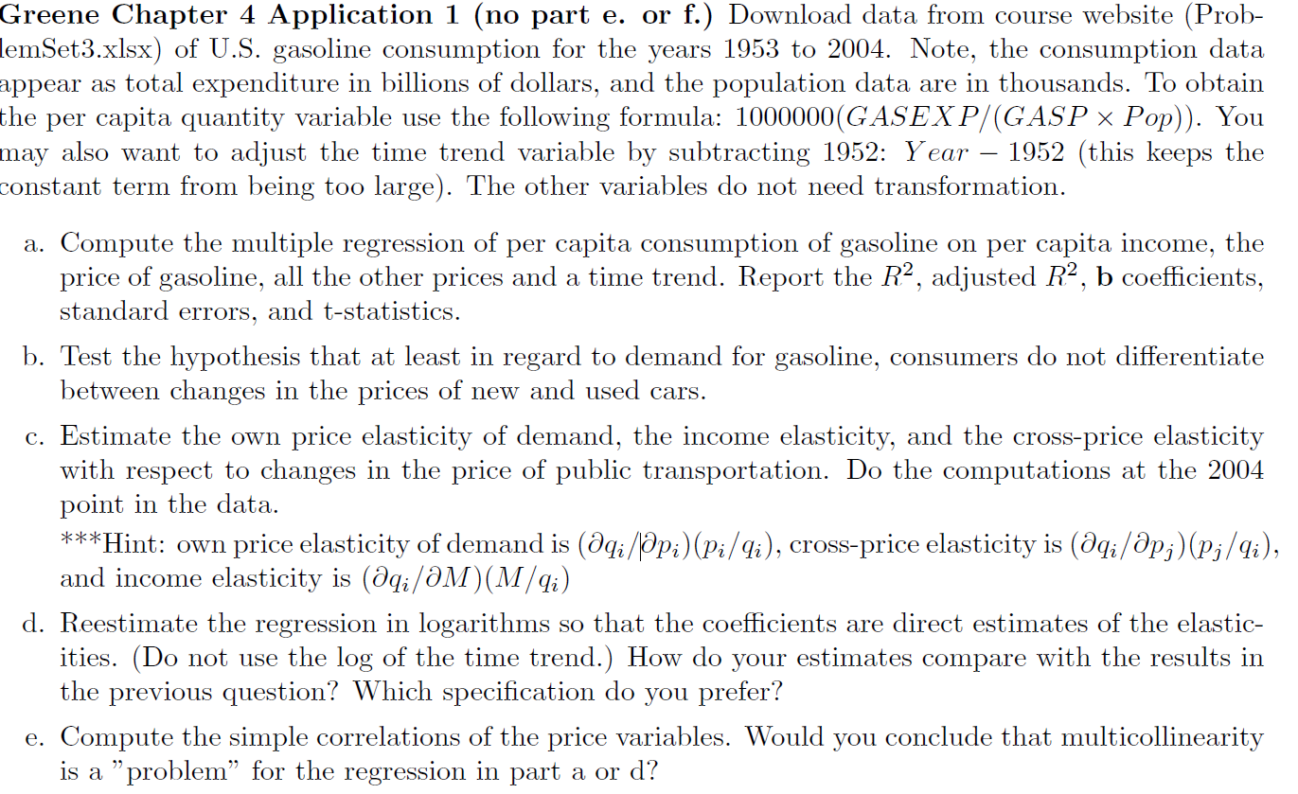

/* Analysis of US Gasoline Consumption Data from 1953 to 2004 */

/* This example appears on Page 106 from Greene */

/* Read the data set */

**data** gasoline;

input Year GasExp Pop Gasp Income PNC PUC PPT PD PN PS;

cards;

1953 7.4 159565 16.668 8883 47.2 26.7 16.8 37.7 29.7 19.4

1954 7.8 162391 17.029 8685 46.5 22.7 18 36.8 29.7 20

1955 8.6 165275 17.21 9137 44.8 21.5 18.5 36.1 29.5 20.4

1956 9.4 168221 17.729 9436 46.1 20.7 19.2 36.1 29.9 20.9

1957 10.2 171274 18.497 9534 48.5 23.2 19.9 37.2 30.9 21.8

1958 10.6 174141 18.316 9343 50 24 20.9 37.8 31.7 22.6

1959 11.3 177130 18.576 9738 52.2 26.8 21.5 38.4 31.5 23.3

1960 12 180760 19.112 9770 51.5 25 22.2 38.1 32 24.1

1961 12 183742 18.924 9843 51.5 26 23.2 38.1 32.2 24.5

1962 12.6 186590 19.043 10226 51.3 28.4 24 38.5 32.5 25

1963 13 189300 18.997 10398 51 28.7 24.3 38.6 32.9 25.5

1964 13.6 191927 18.873 11051 50.9 30 24.7 39 33.2 26

1965 14.8 194347 19.587 11430 49.7 29.8 25.2 38.8 33.8 26.6

1966 16 196599 20.038 11981 48.8 29 26.1 38.9 35.1 27.6

1967 17.1 198752 20.7 12418 49.3 29.9 27.4 39.4 35.7 28.8

1968 18.6 200745 21.005 12932 50.7 30.7 28.7 40.7 37.1 30.3

1969 20.5 202736 21.696 13060 51.5 30.9 30.9 42.2 38.9 32.4

1970 21.9 205089 21.89 13567 53 31.2 35.2 44.1 40.8 35

1971 23.2 207692 22.05 14008 55.2 33 37.8 46 42.1 37

1972 24.4 209924 22.336 14270 54.7 33.1 39.3 46.9 43.5 38.4

1973 28.1 211939 24.473 15309 54.8 35.2 39.7 48.1 47.5 40.1

1974 36.1 213898 33.059 15074 57.9 36.7 40.6 51.5 54 43.8

1975 39.7 215981 35.278 15555 62.9 43.8 43.5 57.4 58.3 48

1976 43 218086 36.777 15693 66.9 50.3 47.8 60.9 60.5 52

1977 46.9 220289 38.907 15991 70.4 54.7 50 64.4 64 56

1978 50.1 222629 40.597 16674 75.8 55.8 51.5 68.6 68.6 60.8

1979 66.2 225106 54.406 16843 81.8 60.2 54.9 75.4 77.2 67.5

1980 86.7 227726 75.509 16711 88.4 62.3 69 83 87.6 77.9

1981 97.9 230008 84.018 17046 93.7 76.9 85.6 89.6 95.2 88.1

1982 94.1 232218 79.768 17429 97.4 88.8 94.9 95.1 97.8 96

1983 93.1 234333 77.16 17659 99.9 98.7 99.5 99.8 99.7 99.4

1984 94.6 236394 76.005 18922 102.8 112.5 105.7 105.1 102.5 104.6

1985 97.2 238506 76.619 19622 106.1 113.7 110.5 106.8 104.8 109.9

1986 80.1 240683 60.175 19944 110.6 108.8 117 106.6 103.5 115.4

1987 85.4 242843 62.488 19802 114.6 113.1 121.1 108.2 107.5 120.2

1988 88.3 245061 63.017 20682 116.9 118 123.3 110.4 111.8 125.7

1989 98.6 247387 68.837 21048 119.2 120.4 129.5 112.2 118.2 131.9

1990 111.2 250181 78.385 21379 121 117.6 142.6 113.4 126 139.2

1991 108.5 253530 77.338 21129 125.3 118.1 148.9 116 130.3 146.3

1992 112.4 256922 77.04 21505 128.4 123.2 151.4 118.6 132.8 152

1993 114.1 260282 76.257 21515 131.5 133.9 167 121.3 135.1 157.9

1994 116.2 263455 76.614 21797 136 141.7 172 124.8 136.8 163.1

1995 120.2 266588 77.826 22100 139 156.5 175.9 128 139.3 168.7

1996 130.4 269714 82.596 22506 141.4 157 181.9 129.4 143.5 174.1

1997 134.4 272958 82.579 22944 141.7 151.1 186.7 128.7 146.4 179.4

1998 122.4 276154 71.874 24079 140.7 150.6 190.3 127.6 146.9 184.2

1999 137.9 279328 78.207 24464 139.6 152 197.7 126 151.2 188.8

2000 175.7 282429 100 25380 139.6 155.8 209.6 125.4 158.2 195.3

2001 171.6 285366 96.289 25449 138.9 158.7 210.6 124.6 160.6 203.4

2002 163.4 288217 90.405 26352 137.3 152 207.4 121.4 161.1 209.8

2003 191.3 291073 105.154 26437 134.7 142.9 209.3 117.5 165.3 216.5

2004 224.5 293951 123.901 27113 133.9 133.3 209.1 114.8 172.2 222.8

;

/* Check the quality of the data set */

**proc** **contents** data=gasoline;

**run**;

**proc** **print** data=gasoline;

**run**;

/* Transform the data as suggested in the assignment writeup */

**data** gasoline;

set gasoline;

per_cap=**1000000**\*(gasexp/(gasp*pop));

time=year-**1952**;

**run**;

**proc** **print** data=gasoline;

**run**;

/* This is Part A */

**proc** **reg** data=gasoline;

model per_cap=Income Gasp PNC PUC PPT PD PN PS time;

**run**;

/* This is Part B */

**proc** **reg** data=gasoline;

model per_cap=Income Gasp PNC PUC PPT PD PN PS time;

restrict PNC-PUC=**0**;

**run**;

/* This is Part C */

/* Get the coefficients of the three variables of interest from Part A */

**data** PartC;

E_pg=-**0.01108** * **123.901**/**6.16406**;

E_M=**0.00021575**\***27113**/**6.16406**;

E_PPT=**0.00691**\***209.1**/**6.16406**;

**run**;

**proc** **print** data=PartC;

**run**;

/* This is Part D */

**data** PartD;

set gasoline;

L_per_cap=log(per_cap);

L_income=log(income);

L_Gasp=log(gasp);

L_PNC=log(pnc);

L_PUC=log(puc);

L_PPT=log(ppt);

L_pd=Log(pd);

L_PN=log(pn);

L_PS=log(ps);

**run**;

**proc** **reg** data=PartD;

model L_per_cap=L_Income L_Gasp L_PNC L_PUC L_PPT L_PD L_PN L_PS time;

**run**;

/* This is Part E */

**proc** **corr** data=gasoline;

var Gasp PNC PUC PPT PD PN PS;

**run**;